IRSTI 39.01.94 DOI

Zh.O. Ozgeldinova¹, A.A. Zhanguzhina^{1,*} , Zh.T. Mukayev² ,
А.A. Bektemirova³, L.M.Korytny⁴, G.Т. Ospan¹

¹L.N. Gumilyov Eurasian National University, Astana, Kazakhstan
²Shakarim University, Semey, Kazakhstan
³Manash Kozybayev North Kazakhstan University, Petropavl, Kazakhstan
⁴V.B. Sochava Institute of Geography of the Siberian Branch of the Russian Academy of Sciences, Irkutsk, Russia
*e-mail: altyn8828@mail.ru

THE SPATIAL STRUCTURE OF NATURE USE CONFLICTS IN THE KOSTANAY REGION

In scientific research, modern conflicts of natural resource use have been identified in the territory of the Kostanay region, and their mapping has been conducted. Landsat 9 satellite images and the results of field research conducted in 2023 were used as the initial data for mapping the structure of conflicts of natural resource use. As a result of the research, the spatial structure of conflicts of natural resource use in the studied area was determined, and the degree of their expression was defined. Based on the analysis of the spatial-territorial structure of natural resource use, the authors have developed a map of natural resource use and a map of conflicts of natural resource use for the studied region. The authors identified and analyzed that the most pronounced conflicts of natural resource use have arisen between the following types of conflicts: settlement-nature conservation; settlement-transport-industrial; recreational-transport; nature conservation-transport-industrial; water management-transport-industrial; and forestry-transport. During the research, it was determined that the collision of interests in antagonistic relationships not only complicates the state of the natural environment of the studied region but also contributes to the destruction and gradual degradation of components of the natural environment, forming strongly expressed multifunctional conflicts of natural resource use. The results of the conducted research can be applied to optimize the territorial-spatial structure of natural resource use and to organize environmental monitoring in the Kostanay region.
Key words: type of nature management, conflict of nature management, antagonistic functions, the spatial structure of nature management, the Kostanay region.

Ж.О. Озгединова¹, А.А. Жангужина^{1,*}, Ж.Т. Мукаев², А.А. Бектемирова³,
Л.М. Корытный⁴, Г.Т.Оспан¹

¹Л.Н. Гумилев атындағы Еуразия ұлттық университеті, Астана, Қазақстан,
² Шәкәрім Университеті, Семей, Қазақстан,
³Манаш Қозыбаев атындағы Солтүстік Қазақстан университеті, Петропавл, Қазақстан
⁴Ресей Ғылым академиясының Сібір бөлімінің В.Б. Сочава атындағы География институты, Иркутск, Ресей
*e-mail: altyn8828@mail.ru

Қостанай облысының табиғатты пайдалану шиеленістерінің
кеңістіктік құрылымы

Ғылыми зерттеу барысында Қостанай облысының аумағындағы табиғатты пайдаланудың заманауи шиеленістері анықталды, оларды картаға түсіру жұмыстары жүргізілді. Табиғатты пайдалану шиеленістерін құрылымын картаға түсіру үшін Landsat 9 ғарыштық суреттері және 2023 жылы жүргізілген далалық зерттеулердің нәтижелері пайдаланылды. Зерттеу нәтижесінде зерттелетін аймақтың табиғатты пайдалану жұмыстарын шиеленістерінің кеңістіктік құрылымы мен олардын деңгейі анықталды. Авторлар аумақтың табиғатты пайдаланудың кеңістіктік-аумақтық құрылымын талдау негізінде зерттелетін аймақтың табиғатты пайдалану картасы мен табиғатты пайдалану шиеленістердін картасын әзірледі. Авторлар табиғатты пайдалану шиеленістерінің неғұрлым айқын көрінетіні анықтады және талдады: селитебті - табиғатты қорғау; селитебті – көліктік-өнеркәсіптік; рекреациялық – көліктік; табиғатты қорғау – көліктік-өнеркәсіптік; су шаруашылығы – көліктік-өнеркәсіптік; орман шаруашылығы – көліктік. Зерттеу барысында антогонистік қатынастардағы функциялардың мүдделерінің қақтығысы зерттеу аймағының табиғи ортасының жағдайын қиындатып қана қоймай, сонымен бірге табиғи ортаның компоненттерінің жойылуына, біртіндеп деградациясына ықпал етіп, табиғатты пайдаланудың айқын полифункционалды шиеленістерін қалыптастыратыны анықталды. Жүргізілген зерттеулердің нәтижелері табиғат пайдаланудың аумақтық-кеңістіктік құрылымын оңтайландыру және Қостанай облысында қоршаған ортаның экологиялық мониторингін ұйымдастыру үшін қолданылуы мүмкін.
Түйін сөздер: табиғатты пайдалану түрі, табиғатты пайдалану шиеленісі, антагонистік функциялар, табиғатты пайдаланудың кеңістіктік құрылымы, Қостанай облысы.

Ж.О. Озгединова¹, А.А. Жангужина^{1,*}, Ж.Т. Мукаев², А.А. Бектемирова³,
Л.М. Корытный⁴ , Г.Т.Оспан¹

¹Евразийский национальный университет имени Л.Н.Гумилева, Астана, Казахстан
²Северо-Казахстанский университет им. М. Козыбаева, Петропавловск, Казахстан
³Университет Шакарима, Семей, Казахстан
⁴Институт географии имени В. Б. Сочавы Сибирского отделения Российской академии наук, Иркутск, Россия
*e-mail: altyn8828@mail.ru

Пространственная структура конфликтов природопользования
Костанайской области

В процессе научного исследования выявлены современные конфликты природопользования на территории Костанайской области и проведено их картографирование. Исходными данными для картирования структуры конфликтов природопользования были применены космические снимки Landsat 9 и результаты полевых исследований, проведенных в 2023 году. В результате исследования была определена пространственная структура конфликтов природопользования исследуемой области и определена степень их выраженности. Авторами разработаны на основе анализа пространственно-территориальной структуры природопользования территории карта природопользования исследуемого региона, карта конфликтов природопользования. Выявлено и проанализировано авторами, что наиболее выраженные конфликты природопользования сложились между следующими видами конфликтов природопользования: селитебный - природоохранный; селитебный – транспортно-промышленный; рекреационно – транспортный; природоохранный – транспортно-промышленный; водохозяйственный – транспортно-промышленный; лесохозяйственный – транспортный. В процессе исследования определено, что столкновение интересов функций при антагонистических отношениях не только усложняет состояние природной среды региона исследования, но и способствует разрушению, постепенной деградации компонентов природной среды, образуя ярко выраженные полифункциональные конфликты природопользования. Результаты проведенных исследований могут быть применены для оптимизации территориально-пространственной структуры природопользования и организации экологического мониторинга окружающей среды в Костанайской области.
Ключевые слова: тип природопользования, конфликт природопользования, антагонистические функции, пространственная структура природопользования, Костанайская область.

Introduction
The issues in the relationship between the natural environment and society in modern conditions are of urgent concern. The increasing anthropogenic impact on the environment in various forms can gradually lead to the disruption of the relationship between society's system and nature. The growth of industrial and economic activities, coupled with the advancement of scientific and technological processes, suppresses the environment's geoecological state and disrupts the ecological balance (Drozdov A.V. et al., 2006: 350).
Nature management – is one of the key aspects of this interaction and, along with it, is a type of activity involving the exploitation of natural resources in the course of anthropogenic actions to meet the essential needs of the modern world.
Nature management is understood as any activity related to the study, exploitation, and restoration of natural resources, and conditions. In nature management, three important stages can be identified – these are the study and analysis of natural resources, nature-consuming, nature-restoring, and nature conservation activities.
In contemporary conditions, the process of transitioning to rational nature management is occurring slowly and inconsistently. Recently, the evolving situation in nature management often leads to the creation of conditions that threaten the sustainable development of regions. It is worth noting that conflicts between different types of nature management have emerged in several territories in Kazakhstan due to the exploitation of the same natural resources by various users.
One of the most negative processes arising from the combination of various factors related to economic and other human activities is the conflicts of natural resource use. The emergence of conflicts in natural resource use gives rise to processes that lead to the violation of established norms for the natural environment, resulting in negative ecological consequences. Identifying conflicts, as well as preventing and subsequently resolving them, are essential stages in the system of natural resource management (Barmin A.N.et al., 2011: 72).
Among all types of conflicts, conflicts of environmental management occupy an insignificant position, but the deterioration of the geo-ecological situation in the world acutely shows the problem of the relationship between nature and society. The conflict of nature management in the scientific literature is mainly described as a contradiction (two or more parties, nature users). This conflict arises in the system of the nature user and the natural environment (Hersperger A. et al., 2015: ).
The study and exploration of literature in the field of natural resource use conflicts have revealed that there is a limited amount of accumulated material on this subject. Currently, many authors have developed methodologies for typifying natural resource use conflicts. The most comprehensive examination of natural resource use conflicts is presented in A.V. Drozdov, N.A. Alexeenko's (2006) works, N.S. Shuvaeva, A.N. Barmin (2012), Henriquez, C., Morales (2022), Tekletsadik S., Degefa S. (2023), Kim, I., Arnhold, S. (2018), Gregg B. Walker, Steven E. D. (2019).
In conflictology, there is a concept of antagonism, which is characterized by a form of contradictions, expressed by contradictions, expressed by the irreconcilability of opposing sides and interests. Thus, in nature management, functions that cannot divide the territory are considered antagonistic. This phenomenon occurs when a certain territory, in our case the landscape, is used for various types of functions that are incompatible with each other. Functions in such a territorial position are located somewhat further from each other, which is enough to absorb the influence of antagonistic functions. The collision of antagonistic functions not only complicates the state of the natural environment but also contributes to the destruction and degradation of the the geosystem components, forming pronounced multifunctional conflicts of environmental management. As a result, difficulties arise, such as not combining the interests of antagonistic functions. The formation of buffer territories makes it possible to reduce the influence of antagonistic functions on each other and solve the situation that has arisen (Chukanova O.A.et al., 2004: 11).
The main reasons for the formation of conflicts in environmental management: 1) simultaneous environmental and economical use of the territory; 2) weak research of the scientific foundations of the methodology for managing the structure of environmental management; 3) weak development of legal environmental management; 4) lack of qualified specialists; 5) weak development of the territorial and functional management system of the structure of environmental management.
The map of conflicts of nature management in nature management can give a clearer expression to the search for solutions to the conflicts between nature users
The purpose of the research is to identify and analyze the spatial structure of the conflict’s types of environmental management in the Kostanay region.

Materials and Methods
At the initial stage of the study, Landsat-9 satellite images (July 2023), field research materials for the summer period of 2023 with GPS-binding, which are integrated into a single cartographic projection and coordinate system, were used as the initial material for mapping environmental management's conflicts in the Kostanay region. The main stages of identifying the types of environmental management's conflicts in the Kostanay region include:
• Collection and processing of data on the natural components of the Kostanay region with the compilation of cartographic material of the object of study using remote sensing data;
• Drawing up a map of the Kostanay region's nature management based on field research, satellite images, and special literature. The cartographic method is of great importance in the analysis and assessment of nature's manifestation of conflicts in environmental management. This method consists of creating a map as a figurative-symbolic model with a spatial-temporal similarity to an object and using maps to study the phenomena reflected in them;
• Identification and analysis of environmental management's conflicts in the territory of the Kostanay region;
• Making a map of environmental management's conflicts in the territory of the Kostanay region;
• Analysis of the structural characteristics of environmental management conflicts in the Kostanay region: dynamics, territorial, and temporal aspects;
• Analysis of the obtained research results, development of recommendations for optimization and improvement of the spatial structure of environmental management in the studied region.

Results and discussion
It became possible to trace various kinds of conflicts of nature management as a result of drawing up a map of the nature management of the studied region, where it is possible to determine the types of conflicts of nature management (Figure 1).

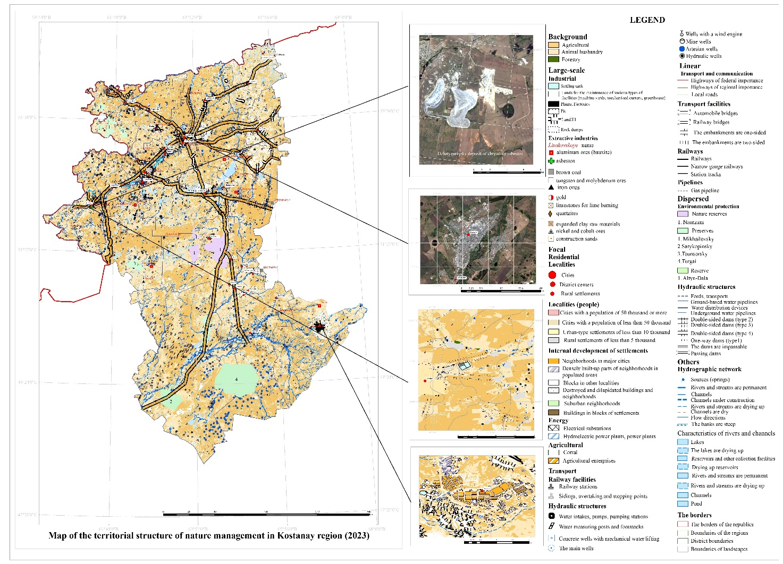
Figure 1 - Map of the territorial structure of nature management in the Kostanay region (2023)

For a systematic analysis of environmental management for the Kostanay region and its mapping, the authors used as a basis the classification of environmental management developed at the IG RAS by T.G. Runova et al. (Runova T. G. et al., 1993: 155). The following types of territorial structures of nature management are identified in the study area: background, large-focal, focal, dispersed, and linear (Table 1).

Table 1 - Classification of types of environmental management in Kostanay region

Group | View | Type | Facilities
Resource-saving | Background | Pedological | Arable land
 |  | livestock | Pastures
 |  | Forestry | Forestry territories
 | Dispersed | Environmental protection | State Nature Reserves, Reserves, Botanical and Zoological Reserves, Natural Monuments
Resource-consuming | Large-scale | Industrial | Mineral deposits  plants, factories, landfills, rock dumps, industrial enterprises, sedimentation tanks
 | Focal | Residential | Residential construction sites
 |  | Energy | Power plants  Electric substations, hydroelectric power plants,
 |  | Agricultural | Agricultural enterprises, livestock pens
 |  | Transport | Railway and hydraulic structures
 | Linear | Transport and communication | Unpaved roads,  Paved roads,  Footpaths  Transportation structures  Pipeline networks  Communication and power transmission lines

Background (traditional) nature management is based on the territorial use of natural resources of the studied region and is associated with the zonal features of natural geosystems;
Large–scale environmental management is represented by an areal, group type of territorial location of production systems that use and process natural resources, which is accompanied by man-made environmental pollution;
Focal nature management is associated with production systems that do not cause significant changes in the environment outside the zones of operation; orientation toward the preservation of natural geosystems;
Dispersed nature management includes certain types of economic activities that are focused on a certain combination of natural properties of landscapes and their maximum conservation. Recreational areas, nature reserves, national parks, and other specially protected natural areas are located within natural geosystems.
In the studied region, large-scale industrial and focal residential environmental management compete with dispersed and background environmental management, and as a result, various types of environmental management conflicts are formed in the Kostanay region.
Such pairs within the studied region include (Henriquez. C. et al., 2022: 332): residential - environmental; residential- transport-industrial; recreational-transport; environmental-transport-industrial; water management-transport-industrial; forestry- transport.
The authors of the work have identified the following pairs of types of environmental management that create conflicts of environmental management in the studied region. Such pairs include:
Residential-environmental conflict arises as a result of antagonistic contradictions between residential and environmental types of nature management. In particular, as a result of the construction of settlements, residential and industrial construction on sites of nature-protected areas, or the neighborhood of residential facilities with nature-protected ones. The residential factor hurts nature conservation areas. Prolonged anthropogenic impact, in this case residential, leads to a gradual deterioration of the natural environment of the protected area (Novoselov A. et al., 2022: 407).
Conflict zones of nature management were formed as a result of the relationship between residential and environmental functions and are confined to the borders of specially protected areas: The Altyn-Dala State Nature Reserve, the Naurzum State Nature Reserve, the Mikhailov, and Tounsor Nature Reserves. The village of Naurzum is located in the central part of the Naurzum Reserve, and in the northeastern part of the Mikhailov State Reserve - part of the territories of the settlements of Slavenka and S. Manas Cordon, forming conflicts of nature use of the area coverage in these territories.
Within the Altyn Dala Reserve, consisting of three localized territories, the following populated areas are located: in the Sarykopa district (Saryqopa lakes group) - the village of Kumshik, in the Uly-Zhylanshyk district (semi-desert areas and the Uly-Zhylanshyk river section) - the village of Ayyrqum, in the Tosymkum district (Tosynkum sands and the left bank of the Torgai River) - the village of Rakhmet.
The most acute conflict situations were formed in the system of antagonism "residential-transport-industrial". This type of conflict of environmental management is characterized by the location of transport and industrial facilities about residential ones within the radius of the zone of negative impact (less than 1 km), since in this radius of the neighborhood of antagonistic functions there is a noticeable consolidation of the transport network (Order of the Acting Minister of Health of the Republic of Kazakhstan dated January 11, 2022, No. KR DSM-2. On the approval of Sanitary rules "Sanitary and epidemiological requirements for sanitary protection zones of objects that are objects of impact on the environment and human health").
The type of antagonistic relations "Residential-transport-industrial" is the most common conflict in the studied region. The territories of residential-transport-industrial conflicts are confined to mineral deposits that are located in areas of conflict situations in nature management including the Borovsk quartzite deposit, Smirnovsk molybdenum-tungsten deposit, Sokolovsko-Sarbaysk iron ore deposit, Zhitikarin chrysotile asbestos deposit, Sunalyksk construction materials deposit, Kushmurunsk brown coal deposit, Vostochno-Ayatsk bauxite deposit, Belinsk bauxite deposit, Zapadno-Ubagan bauxite deposit (Medeu A.R. et al., 2006).
A multifunctional conflict has arisen between recreational and transportation forms of nature use in areas with forest recreational and nature conservation sites that have formed within the radius of negative impact on transportation facilities. Recreational zones experience oppressive anthropogenic influence as a result of the development and construction of transportation infrastructure (Karmanov I. I. et al., 1998: 65). The impact of the transportation factor gradually leads to soil cover compaction and degradation, as well as a reduction in the productivity of meadows and pasture areas. It should be noted that in the recreational zones of the Kostanay region, this type of impact becomes particularly acute. Road embankments often turn into dams and become the cause of extensive waterlogging in specific areas. The transportation form of nature use also leads to dusting and chemical pollution of the vegetation cover. Sometimes, the destruction of vegetation along the transportation routes in the studied region can be observed. Primarily, increased road digression with severe disturbances is associated with asphalt and graded transport paths. The development of soil water and wind erosion processes and the transformation of the vegetation cover are direct consequences of road digression (Mukayev Z.T. et al., 2020: 352).
In the Kostanay region, the most popular recreational areas include the pine forests of Arakaragai and Amankaragai, as well as the areas surrounding the city of Kostanay (Auliekol, Altynsarin, Naurzum districts of the Kostanay region). In these areas, sanatoriums, tourist bases, health complexes, and other organized and unorganized recreational zones are located.
The growth of unorganized recreational areas for the local population gradually leads to tension and disruption of the ecological condition of forests. This situation arises not universally but mainly around recreational zones (recreation bases, cottage areas, children's and educational health camps, and transportation routes). The absence of road and trail networks in mass recreation areas frequently encountered waterlogged areas, and a low level of improvement in the forests of suburban areas impose restrictions on the movement of recreation seekers and the local population. In these areas, processes such as changes in vegetation types, littering, trampling, and, in some places, burning of the vegetation cover, compaction of the upper layer of the soil horizon, tree cutting, desertification, etc., are evident. An increase in recreational impact on forest vegetation is observed in the most visited recreation areas within the pine forests of Amanakaragai (Auliekol district) and Arakaragai (Altynsarin district).
The Amanakaragai Pine Forest is adjacent to the southern part of the Kostanay Plain, with a length of 45 km and a width of 14.5 km. This pine forest is considered the largest isolated forest massif in the studied region, covering an area of 60 thousand hectares. It primarily consists of pine trees, with significant areas occupied by birch and aspen groves as well. A botanical monument covering an area of 5 hectares is located in the Karagash tract. During the warm seasons, residents from nearby settlements engage in berry and mushroom picking in the surrounding forest. The pine forest, along with birch and aspen groves, waterlogged areas, and numerous small freshwater and saline lakes in the interdunal depressions, annually attracts a large number of tourists and recreation seekers.
In the Arakaragai Pine Forest, covering an area of 616 km² (forest area - 271 km²), pine trees, birches, and aspens thrive. Timber harvesting is conducted in the forest area (1 hectare yields 25-350 m² of timber), which negatively impacts the ecology of the studied territory.
The enterprises LLP "Sanatorium Sosnovy Bor," LLP "Dzhailau," LLP "Selena," and several tourist bases and recreation areas located in the forestry zone of Arakaragai contribute to a multifunctional conflict in the region's nature use. The further growth of recreational impact on the studied region will lead to an expansion of conflict-prone areas in natural use. Landscape types where areas with recreational-transportation conflict zones in nature use are present include 22, 43, and 74 landscape types.
Conflict areas in nature use arise from the formation of an antagonistic relationship between nature conservation and transportation-industrial functions. Transport and industrial facilities, located within the radius of negative impact, exert unfavorable anthropogenic influence on nature conservation areas. The primary area of conflict in the nature use of the studied region has developed within the nature conservation zones of the Tounsor Reserve and the Uly-Zhylanshyk section of the Altyn Dala Reserve, where mineral deposits are situated.

The first area identified by us is located within the territory of the Tounsor State Reserve, near which, within the radius of negative impact (960 m), the Tounsor bauxite deposit is situated. Seventy percent of its reserves consist of underground freshwater from the Zholsharin and Naurzum deposits. The expansion of the industrial zone could destroy the unique natural environment of the region and lead to the depletion of underground freshwater resources. Currently, bauxite extraction is not permitted within the reserve area.
Within the Uly-Zhylanshyk section of the Altyn Dala Reserve, Uly in the southeast of the Turgai trough, the Zhilanshik coal basin is situated, covering an area of about 20,000 km². The basin is associated with coal deposits such as Zharkue, Altynzhar, Balattam, Kaidagul, and Sirlytam, as well as coal deposits Bestobe, Kargalytau, and Turgai. The location of the coal basin within the reserve may negatively impact the geoecological condition of this specially protected area in the future. Currently, the economic activities of enterprises adjacent to the protected zone of the Altyn Dala Reserve and Tounsor Reserve are strictly regulated by the articles of the Law of the Republic of Kazakhstan dated 07.07.2006 N 175-III ZRK "On Specially Protected Natural Areas". The Naursum Reserve and the western section of the Altyn Dala Reserve experience a significant transportation burden due to the passage of major international corridors of highways.
In the Kostanay region, an antagonistic relationship has also developed between water management and transportation-industrial forms of nature use. According to the requirements of regulatory documents for the protection of water protection zones in the Republic of Kazakhstan, any economic activity is prohibited within the territories designated as water protection zones. However, some water management zones observe violations and non-compliance with environmental requirements. Industrial activities and the construction of residential and industrial facilities are taking place in certain areas designated as water protection zones. In the Kostanay region, a multifunctional conflict in nature use has arisen in the areas of water bodies such as the Tobol, Ayat, and Toguzak rivers, and within the Karatomar Reservoir.
Mining operations for the development of the largest gold and copper deposit, "Varvarinsk," are taking place in the water management zone of the Ayat River. It is important to note that the "Varvarinsk" deposit is the largest in terms of confirmed reserves in the Kostanay region and includes a quarry and a modern gold extraction and enrichment factory with a capacity of 4.2 million tons per year. Within the water management zone of the Karatomar Reservoir, there are residential and industrial lands (the village of Ayet, the industrial zone of the village of Elizavetinka), as well as areas designated for catering services (the "Koktem" cafe, the Beymbet Maylin district of the Kostanay region) and the construction of a broiler poultry farm.
The development of a construction stone deposit is taking place in the vicinity of the village of Nadezhdinka in the Karabalak district, disrupting the land structure of the floodplain of the Toguzak River. Additionally, within the water protection zone of the Toguzak River, there is a production site of the "Komsomolskaya Poultry Farm" joint-stock company.
It should be noted that the extensive banks of the Tobol River, its tributaries, and other bodies of water are attractive places for tourists and recreation seekers. Construction along the banks of the Tobol River is carried out within a water protection zone of 500-1000 meters, where infrastructure such as recreational areas, service facilities, and guest houses that are accessible and comfortable for tourists are being erected and reconstructed. Additionally, lands have been allocated for the construction of a sports and recreational complex for tourist services and a "Tourist Supermarket for Comprehensive Servicing of a Tourist Cottage Town" in the territory of the Michurinsk rural district.
The water management and transportation-industrial conflict of land use is also evident within the Karatomar and Amangel'din reservoirs, where on the territories designated for water protection zones, there are bases for recreational areas, tourist and health complexes, as well as several tourist bases ("Zolotaya Rybka," "Parallel," "Druzhba").
Conflicts of nature use within the antagonistic relationship system of "forestry-transport" are characteristic of the forested areas of Amanqaragay, Arakaragay pine forests, and other forested territories in the Kostanay region.
Transport arteries hurt forest landscapes, causing suppression of vegetation and other disruptions to the natural state of the ecosystem.
Alongside these conflicts of nature use, conflicts characterized by two or three forms of antagonistic relationships are emerging. The areas of the Kostanay region where residential, transportation-industrial, and recreational functions are simultaneously implemented include the territories of the cities of Kostanay, Lisakovsk, and Rudny.
The map of conflicts of nature use provides the opportunity to address issues related to optimizing relationships when conflicting antagonistic functions of nature use collide. It allows for the analysis of the situation in nature use and can be applied to enhance functional zoning and develop environmental recommendations, among other purposes. The increasing pace of anthropogenic impact in the future will lead to the emergence of more complex polyfunctional conflicts of nature use in the studied region.
The next stage of studying conflicts of nature use in the Kostanay region involves the analysis and mapping of nature use conflicts.
The cartographic method makes it possible to use the spatial aspect in the analysis of existing conflicts of environmental management in the studied region. The cartographic representation of environmental management conflicts makes it possible to analyze their spatial location and identify the most geoecologically stressed areas (Figure 2).

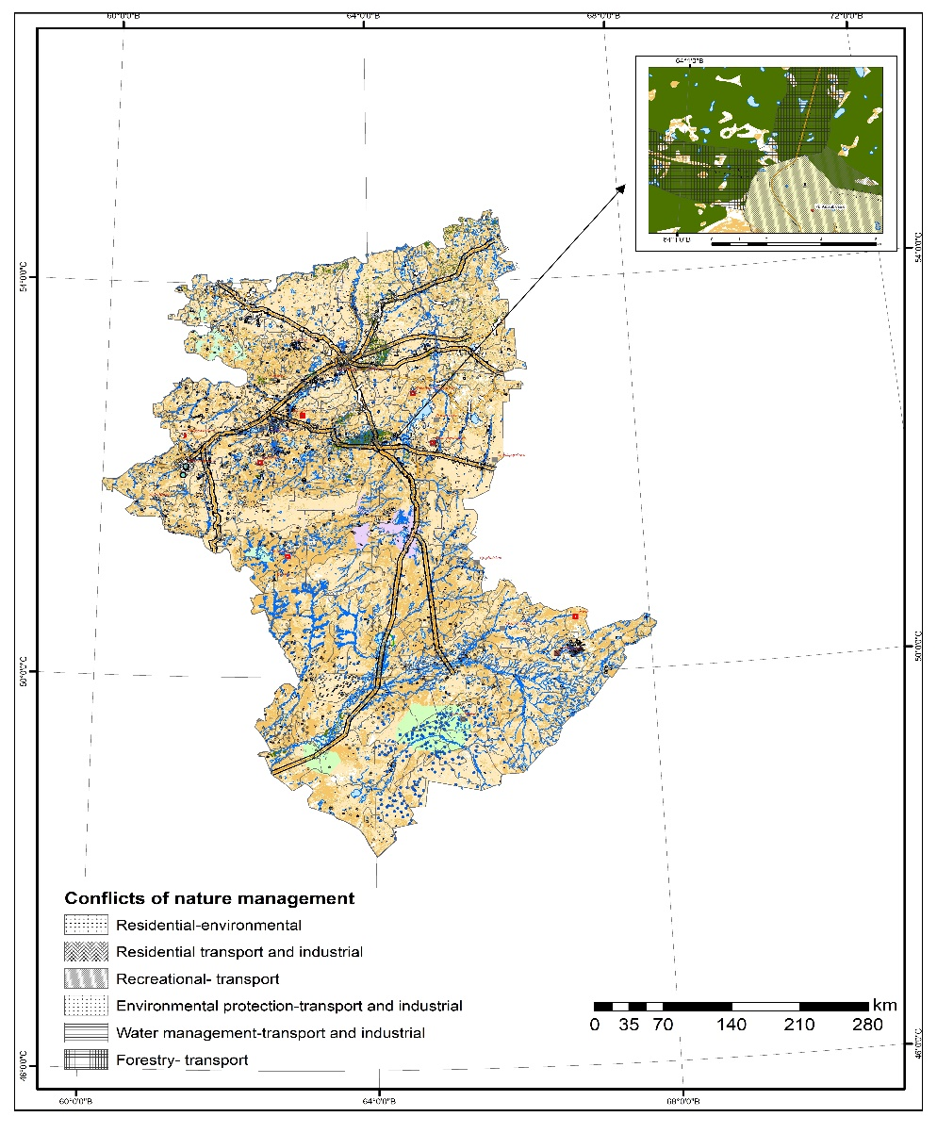
Figure 2 - Map of conflicts of nature management in the Kostanay region

Having researched and studied the conflicts of nature management in the Kostanay region, it can be concluded that most of the presented conflicts have a local distribution in the form of certain areas. The largest number of types of environmental management conflicts in the Kostanay region have a point-focal and linear nature of placement.
For a more detailed analysis of environmental management conflicts, we have identified the following structural characteristics: dynamics, temporal, and territorial aspects (Barmin A.N. et al., 2011).
The dynamics of the conflict of environmental management can be represented by the following forms: increasing, stable, and decreasing. The dynamics of the conflict of environmental management may change annually or seasonally. It depends on the type of behavior of the nature user himself (increase or decrease in the extraction of a natural resource, etc.).
The temporal aspect of the conflict of nature management shows the duration of antagonistic contradictions between certain types of nature users. The territorial aspect shows the spatial scope of the manifestation of the conflict of nature management, its scale, and localization.
The analysis of the study shows that in the Kostanay region, the largest number of conflicts of environmental management belong to groups with the following structural characteristics of conflicts of environmental management: with increasing dynamics, point-focal placement, and year-round temporal aspect (see Table 3).

Table 3 - Structural characteristics of environmental management conflicts: dynamics, temporal, and territorial aspect

Conflict of nature management | Dynamics | The time aspect | The territorial aspect
Residential - environmental | increasing | year-round | Areal
Residential – transport and industrial | increasing | year-round | Linear, point-focal
Recreational and transport | increasing | seasonal | Linear
Environmental protection – transport and industrial | stable | year-round | Linear, point-focal
Water management– transport and industrial | increasing | year-round | Linear, point-focal
Forestry – transport | stable | year-round | Linear

Analyzing the classification given above, we can identify individual conflicts that are similar in structural characteristics (recreational-transport and forestry-transport, residential-transport-industrial, and water management-transport-industrial). The similarity of the structural aspects of environmental management conflicts in the Kostanay region does not mean that these conflicts need to be put on par when searching for environmental measures to solve the environmental problems that have arisen.
Thus, the study of antagonistic functions in nature management allows us to analyze the state of nature management in the conflict areas of the studied region and develop buffer zones that absorb the effects of antagonists on each other. Only a comprehensive analysis of environmental management conflicts, taking into account all structural characteristics in the system of antagonistic relations, can give a positive result when trying to minimize the consequences of conflict situations in environmental management or their complete elimination. The development of rational environmental management in the Kostanay region is possible only if optimal ways of resolving conflicts between different types of environmental management characteristics of this region are applied.

Conclusions:

The existing conflicts of nature management in Kostanay region have been identified and analyzed:
- Residential-environmental;
- Residential transport and industrial;
- Recreational- transport;
- Environmental protection-transport and industrial;
- Water management-transport and industrial;
- Forestry- transport.
It is revealed that the most common types of conflicts of environmental management in the studied region are residential-transport-industrial and recreational-transport.
The structural characteristics of environmental management conflicts in the Kostanay region are analyzed: dynamics, temporal, and territorial aspects. Studies have shown that most conflicts of environmental management relate by structural characteristics to conflicts with increasing dynamics, point-focal and linear territorial aspects, and year-round manifestation.
The spatial structure of environmental management conflicts demonstrates that environmental management conflicts are concentrated near the cities of Kostanay, Rudny, Lisakovsk, and their suburban territories, where several types of environmental management operate simultaneously: residential, transport-industrial, recreational, etc. The following conflicts of nature management are most pronounced in such territories: residential – transport-industrial; recreational – transport; water management-transport-industrial; forestry- transport.
The results of the work performed can be used to improve the existing functional zoning of the Kostanay region, to develop recommendations and proposals for environmental protection measures, and to organize monitoring and optimization of the natural environment of the studied region.

Acknowledgments
This study was conducted within the framework of grant funding for young scientists on scientific and (or) scientific and technical projects for 2022-2024 by the Ministry of Science and Higher Education of the Republic of Kazakhstan (IRN №AP13067925).

References
Barmin A.N., Shuvaev N.S., Kolchin E.A. The experience of mapping conflicts of environmental management on the example of the Astrakhan region. ASU: Arid ecosystems. Vol. 1. № 4 (46), 2011: pp. 72-83.
Chukanova O.A. Functional zoning of the Black Sea coast of Russia for rational nature management: Abstract. ... Candidate of Geographical Sciences. M: 2004, 16 p.
Drozdov A.V., Alekseenko N.A. Landscape planning and conflicts of nature management. Environmental management and sustainable development. M.: Publishing House of the KMK. 2006: pp. 350-369.
Gregg B. Walker, Steven E. D. Collaboration in Environmental Conflict Management and Decision-Making: Comparing Best Practices With Insights From Collaborative Learning Work. Front. Commun: Sec. Science and Environmental Communication. 4(2), 2019: pp.1-12.
Henriquez C., Morales M., Quense J., Hidalgo R. Future land use conflicts: Comparing spatial scenarios for urban-regional planning. Environ. Plan. B Urban Anal. City Sci. Vol. 50, 2022:332–349.
Hersperger A., Ioja C., Hossu C. A., Steiner F. Comprehensive consideration of conflicts in the land-use planning process: A conceptual contribution. Carpathian Journal of Earth and Environmental Sciences 10(4), 2022: pp.5-13
Karmanov I. I., Bulgakov D. S. Soil degradation: proposals for improving terms and definitions. M: 1998, 78 p.
Kim, I., Arnhold. S. Mapping environmental land use conflict potentials and ecosystem services in agricultural watersheds. Sci. Total Environ. 2018: pp. 827–838.
Mukayev Z.T., Ozgeldinova Z.O., Janaleyeva K.M., Ramazanova N.Ye., Zhanguzhina, A.A. Assessment of the tourist recreation capacity of Lake Alakol basin. Geojournal of Tourism and Geosites. 30(2), 2020: pp. 875–879.
National Atlas of the Republic of Kazakhstan / edited by A.R. Medeu et al. Almaty. vol. 1. 2010. 149 p.
Novoselov A., Potravnii I., Novoselova I., Gassiy V. Conflicts Management in Natural Resources Use and Environment Protection on the Regional Level. Journal of Environmental Management & Tourism. 7. 3(15). 2022.: 407-415. DOI:10.14505/jemt. v7.3(15).06
Runova T. G., Volkova I.N., Nefedova T.G. Territorial organization of nature management. M.: Nauka. 1993. 207 p.
Tekletsadik S., Degefa S., Kebede F. Natural Resource Use Conflict and Its Management in Babile ElephantSanctuary, Eastern Ethiopia, Poult Fish Wild Sci, 2023: pp. 11-13

Information about authors:
1. Ozgeldinova Zhanar Ozgeldinovna– PhD, Acting Professor of the Department physical and economic geography of L.N. Gumilyov Eurasian National University (Astana, Kazakhstan, email: ozgeldinova@mail.ru );
2. Zhanguzhina Altyn Amirzhanovna (corresponding author) – PhD, Acting Associate Professor of the Department physical and economic geography of L.N. Gumilyov Eurasian National University (Astana, Kazakhstan, email: altyn@mail.ru);
3. Mukaev Zhandos Toleubekovich – PhD, the Dean of the Faculty of Natural and Mathematical Sciences of Shakarim University (Semey, Kazakhstan, email: zhandos.mukaev@mail.ru);
4. Bektemirova Asel Amangeldyevna – PhD, Senior Lecturer of the Department of Geography and Ecology of the Non-profit limited company "Manash Kozybayev North Kazakhstan university", Master's degree (Petropavl, Kazakhstan, email: asel.8.90@mail.ru @mail.ru);
5. Korytny Leonid Markusovich – Doctor of Geographical Sciences, Professor, Chief Researcher at the V. B. Sochava Institute of Geography of the Siberian Branch of the Russian Academy of Sciences, Chairman of the Irkutsk Regional Branch of the Russian Geographical Society (Irkutsk, Russia, email: kor@irigs.irk.ru);
6. Ospan Gaukhar Tashymkyzy – Master of Science in Natural Sciences of the Department physical and economic geography of L.N. Gumilyov Eurasian National University (Astana, Kazakhstan, email: gauhara_ast@mail.ru).

Авторлар туралы мәлімет:
- Озгелдинова Жанар Озгелдиновна – Л.Н. Гумилев атындағы Еуразия ұлттық университетінің физикалық және экономикалық география кафедрасының профессор м. а. (Астана қ., Қазақстан, эл. пошта: ozgeldinova@mail.ru);
- Жангужина Алтын Амиржановна – (корреспондент-автор) - PhD, Еуразия ұлттық университетінің физикалық және экономикалық география кафедрасының доцент м. а. (Астана, Қазақстан, эл.пошта: altyn@mail.ru );
- Мукаев Жандос Толеубекович – PhD, Шәкәрім университетінің жаратылыстану-математикалық факультетінің деканы (Семей қ., Қазақстан, эл. пошта: zhandos.mukaev@mail.ru );
- Бектемирова Асель Амангельдыевна – PhD, «Манаш Қозыбаев атындағы Солтүстік Қазақстан университетінің» география және экология кафедрасының аға оқытушысы, магистр (Петропавл қ., Қазақстан, эл.пошта: asel.8.90@mail.ru );
- Корытный Леонид Маркусович – Ресей Географиялық қоғамының Иркутск облыстық бөлімінің төрағасы, география ғылымдарының докторы, профессор, Ресей Ғылым академиясының Сібір бөлімінің В. Б. Сочава атындағы География Институтының бас ғылыми қызметкері (Иркутск қ., Ресей, эл.пошта: kor@irigs.irk.ru )
- Оспан Гауһар Тәшімқызы - Л.Н. Гумилев атындағы Еуразия ұлттық университетінің физикалық және экономикалық география кафедрасының жаратылыстану ғылымдарының магистрі (Астана, Қазақстан, эл.пошта: gauhara_ast@mail.ru ).

Received November 25, 2023
Accepted March 27, 2024

